Editing the Transactional Billing

Support fee in the GhostConvey Accounts

✓
Logon to GhostConvey as Supervisor, or as a user with supervisor permissions.
(The default password is "always1")

Once in the System Manager, click on the Setup icon (spanner) to access the Setup module.

To edit the TBS fee in Bonds; from Setup > Bond > Account details.

Select the View User Only radio button, as that will filter the display for the account items to show only USR entries.

Select the TBS entry from the list of entries that appear, and at the bottom of that screen the details for this entry will appear. Make your changes and click on Save.

NOTE: The amount captured here, should include a mark up on the transaction fee. The Law Society of South Africa has approved the off-set of a transaction fee, and allows for attorneys to mark up this fee to cover administration.

For example if your firm is charging a 10% mark up on their transactional billing fee it should appear as below (R89 + 10% = R97.90 ex VAT):

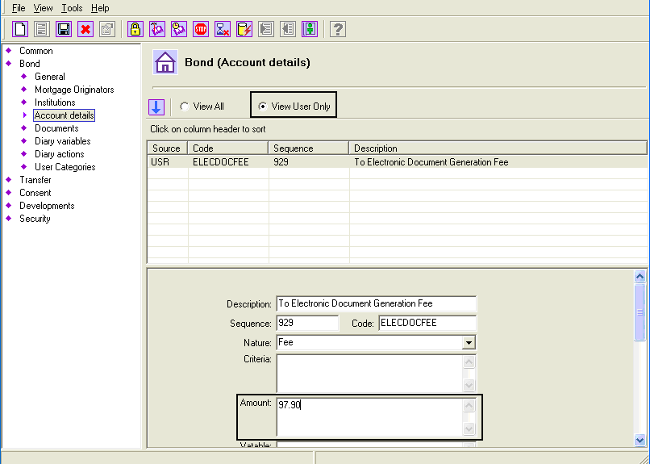

To edit the TBS fee in Transfers, from Setup > Transfer > Account details.

Select the entry from the list of transfer account items, and edit the information that displays on the right hand side. Save the changes.

NOTE: The amount captured here, should include a mark up on the transaction fee. The Law Society of South Africa has approved the off-set of a transaction fee, and allows for attorneys to mark up this fee to cover administration.

NOTE: Ensure the details that have been edited reflect correctly on both the transferee (debit) and firm (credit) entries.

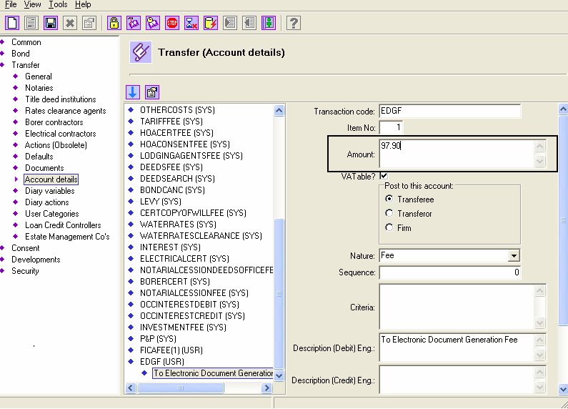

To edit the TBS fee in Consents, from Setup > Consents > General.

Edit the amount that appears in the Document Generation fee. Save the changes.

NOTE: The amount captured here, should include a mark up on the transaction fee. The Law Society of South Africa has approved the off-set of a transaction fee, and allows for attorneys to mark up this fee to cover administration.

The editing is now complete. Close Setup and log off as Supervisor.

Log in to GhostConvey in the normal manner.

