What is BridgingCentral?
BridgingCentral is an online portal that allows attorneys and bridging finance companies to process bridging finance loans.
FAST, ACCURATE, MINIMUM IMPACT

Why should I consider this solution?

Automated process with data extracted from GhostConvey

Choose the bridging finance companies of your choice

Documents and forms all online

Settlement figures calculated on-line

E-mail and SMS notification of main events

Save 90% of the time you used to spend on bridging

Assist your client to raise short-term funds easily

What can it do for me?

INTEGRATION WITH YOUR CONVEYANCING SYSTEM
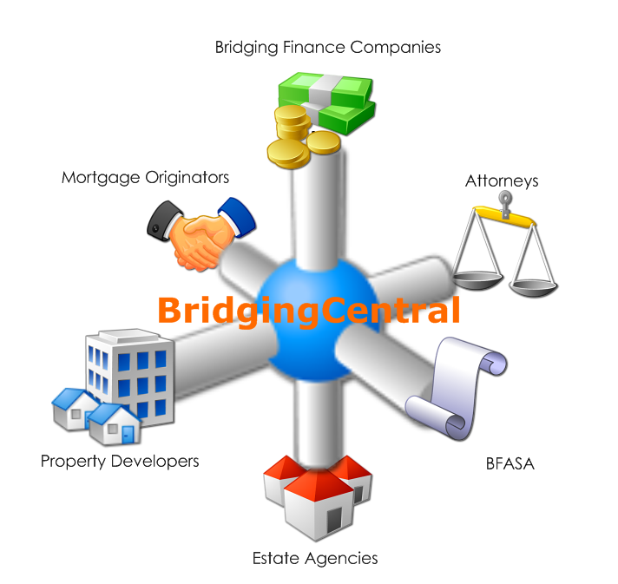
There is no need to double capture your information that is in your conveyancing system. BridgingCentral provides a link for Conveyancing Systems. When a bond or transfer is opened for bridging on the conveyancing system, the information from the conveyancing system is uploaded through a secure service to the website. Any updates to this information are also sent through to the website.

Fast Completion of forms
As BridgingCentral gets most of its information from you conveyancing system, the additional information required for a loan application is minimal.

LAtest Loan Documents
When you make a bridging finance loan application, the latest application forms and supporting documents are always used. Only the documents relevant to that loan are produced.

No more Hard-copy Forms
As the documents are stored in the system, you never need to keep stacks of hard-copy bridging finance documents. The system will generate the latest forms when doing an application.

Immediate communication of Information
Bridging finance applications are made online. The bridging finance company immediately receives the details about the application and can begin processing it.
When you update the information on your side, the bridging finance company can see this update immediately. The same is true for when the Bridging Finance Company approves and pays out the loan, you have this information available.

NOTIFICATION OF IMPORTANT EVENTS
No need to be constantly logged into BridgingCentral to be notified important events on the Loan. BridgingCentral notifies you via email. And what's more, we notify the bridging finance company of your milestones as well on your behalf.

REAL-TIME LOAN SETTLEMENT FIGURES
Get the outstanding amount due on a loan at any time, without any delays. Settlement figures, including initiation fee, services fees, and interest are generated immediately by the system on request.

SELECTION OF BRIDGING FINANCE COMPANIES
BridgingCentral provides services to a number of bridging finance companies, letting you communicate with the bridging finance company of your choice.

INFORMATION IS SECURE
Your information is secure. BridgingCentral makes use of username and password protection to authenticate its users, SSL technology to encrypt the information when working online, and Korbitec Gateway to secure the transmissions between your conveyancing system and BridgingCentral.

No Installations or Updating
BridgingCentral is web-based. There is no need for you to do any software installations or updates.

AVAILABLE 24/7
No need to wait for normal office hours to make an application or request settlement figures, BridgingCentral is always online.

Latest Technologies
BridgingCentral is built using the latest in web technologies

How do I get started?
Attorneys can register to use BridgingCentral by filling out the registration form online at https://www.bridgingcentral.com.
To enable integration with your conveyancing system, you will need to be a Korbitec Gateway user. If you are an existing Korbitec Gateway user, all you need to do is capture your Korbitec Gateway Reference in the Setup of your company on BridgingCentral.
If you are not a Korbitec Gateway user, please contact Korbitec Gateway at
- Email: gateway@korbitec.com
- Phone: 0800 003 8368
Or go to http://www.korbitecgateway.co.za/ to find out more.
For any help needed with registration and getting started, please contact the help desk at 0860 266 839

