Sectional Titles and Other Fragmented Property Schemes
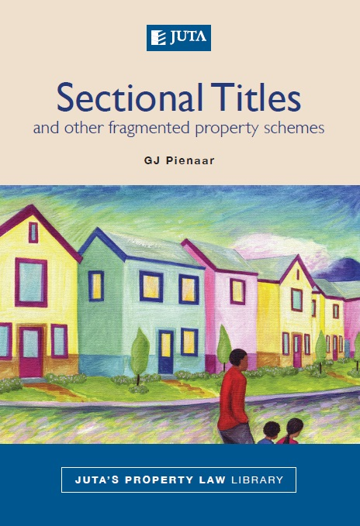
Author: G J Pienaar

Publication date: October 2010

Edition: First

ISBN: 978-0-7021-8553-3

Format: Soft cover

Extent: 582 pages

Price: R450 (incl. VAT, excl. delivery)

About this publication:

Social and economic developments in South Africa have contributed to the increasing need for fragmented property holding, especially in urban areas. With the advent of the wider interpretation of property in terms of the new constitutional dispensation this need has been strengthened. The idea that individualised landownership forms the basis of the South African property concept has been gradually transformed by the reality that sectional titles, share blocks, property time-sharing and retirement schemes are essential forms of urban property holding.

This book provides an exposition of the idea of urban fragmented property holding in South Africa, with reference to the different forms of urban fragmented property schemes introduced by legislation. The functioning of the management bodies of these schemes and the nature and effect of management and conduct rules are emphasised to illustrate to what extent the idea of urban fragmented property holding has changed the property concept in the new constitutional dispensation in South Africa.

Relevant case law and new legislative developments are discussed comprehensively to indicate how fragmented property schemes are governed and how disputes regarding use rights of individual sections and the common property of such schemes are solved.
Sectional Titles and Other Fragmented Property Schemes forms part of Juta’s Property Law Library, a new series aimed at revisiting and reassessing the whole of South African property law. In the long term this collection will consist of a number of monographs, each focused on a specific aspect of property law. The series, which includes uncodified common law that is mostly embodied in case law, academic writing and legislation, establishes:
• how each aspect of property law was influenced by apartheid law
• its response to the new constitutional dispensation and land reform
• whether it can make a contribution towards the transformation of South African law and society.

Contents include:

- Urban fragmented land tenure
- Sectional titles
- Sectional title ownership
- Registration of scheme and units
- Management of a sectional title scheme
- Rights and obligations of owners and other right-holders
- Share blocks
- Share block schemes
- Management of a share block scheme
- Time-sharing
- Time-sharing schemes
- Retirement schemes
- Bibliography
- Case law
- Legislation

Of interest to:

- Academics
- Postgraduates

- Practitioners

 | YOUR CONTACT:
 | Sales Manager  Grace Kironde  • Cell: 076 401 3509  • Tel: +27 (0) 11 217 7200  • Fax: +27 (0) 11 883 8169  • E-mail: gkironde@juta.co.za |  | Gauteng (Advocates), Limpopo, North West & Mpumalanga  Adele Boonzaaier  Business Consultant  • Cell: 083 580 9945  • Tel: +27 (0) 11 217 7200  • Fax: +27 (0) 11 883 8169  • E-mail: aboonzaier@juta.co.za | Gauteng (Corporate)  Brigitte Bentley  Business Consultant  • Cell: 083 629 7524  • Tel: +27 (0) 11 217 7200  • Fax: +27 (0) 11 883 8465  • E-mail: bbentley@juta.co.za
 | Gauteng (Government)  James Selepe  Business Consultant  • Tel: +27 11 217 7200  • Fax: +27 11 883 8169  • Cell: 082 292 7667  • Email: jselepe@juta.co.za |  | Integrated Justice System  & SA Police Service  Pappy Padachy  Key Account Manager  • Cell: 071 673 6958  • Tel: +27 (0) 11 217 7200  • Fax: +27 (0) 11 883 8169  • E-mail: ppadachy@juta.co.za | Gauteng (Attorneys) & Free State  Stefan Kruger  Business Consultant  • Cell: 082 824 6566  • Tel: +27 (0) 11 217 7200  • Fax: +27 (0) 11 883 8169  • E-mail: skruger@juta.co.za
 | KwaZulu-Natal, Lesotho, Botswana, Swaziland & Eastern Cape (incl.  Border area)  Bev Purdon  Business Consultant  • Cell: 083 702 3617  • Tel: +27 (0) 31 304 4335  • Fax: +27 (0) 31 304 4284  • E-mail: bpurdon@juta.co.za |  | Western Cape, Eastern Cape (excl. Border area), Northern Cape & Namibia  Robin White  Business Consultant  • Cell: 079 696 5215  • Tel: +27 (0) 21 659 2431  • Fax: +27 (0) 21 659 2727  • E-mail: rwhite@juta.co.za

Tel: +27 (0) 21 659 2300
email: cserv@juta.co.za
OR
Visit your nearest Juta Bookshop:
Claremont +27 21 670 6680, Parow +27 21 930 6202, Hatfield +27 12 362 5799
Carlton Centre +27 11 331 5140, UJ +27 11 482 3566 & TUT +27 12 382 5918
For more information, visit the website www.jutabookshops.co.za or online purchases at www.jutaonline.co.za

