The Law of Neighbours

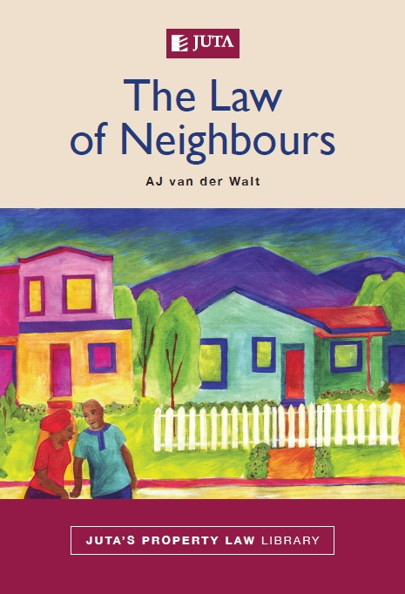

Author: A J Van der Walt

Publication date: October 2010

Edition: First

ISBN: 978-0-7021-1551-9

Format: Soft cover

Extent: 484 pages

Price: R395 (incl. VAT, excl. delivery)

About this publication:

The Law of Neighbours provides a substantive analysis of this area of law. It covers traditional areas of neighbour law, such as party walls and fences, lateral support, encroachment, interference with the natural flow of water, nuisance, and dangers caused by neighbours as well as chapters on neighbour conflicts caused by building, the influence of the new Constitution and the notion of living together as neighbours in the new democracy.

The book aims to establish the current state of the law seen against the context of its historical development in South Africa and in the perspective of foreign law. It is also determines whether and how the current position is consistent with the Constitution.
The Law of Neighbours forms part of Juta’s Property Law Library, a new series aimed at revisiting and reassessing the whole of South African property law. In the long term the collection will consist of a number of monographs, each focused on a specific aspect of property law. This collection includes uncodified common law that is mostly embodied in case law, academic writing and legislation, to establish:
• how each aspect of property law was influenced by apartheid law
• its response to the new constitutional dispensation and land reform
• whether it can make a contribution towards the transformation of South African law and society.

Contents include:

- Living together as neighbours
- Mutual boundaries, party walls and fences
- Lateral support
- Encroachment
- Natural flow of water
- Nuisance
- Dangers and threats posed by neighbours
- Neighbour disputes about building
- Future development
- Bibliography
- Legislation
- Case law
- Index

Of interest to:

- Academics
- Postgraduates
- Practitioners

 | YOUR CONTACT:
 | Sales Manager  Grace Kironde  • Cell: 076 401 3509  • Tel: +27 (0) 11 217 7200  • Fax: +27 (0) 11 883 8169  • E-mail: gkironde@juta.co.za |  | Gauteng (Advocates), Limpopo, North West & Mpumalanga  Adele Boonzaaier  Business Consultant  • Cell: 083 580 9945  • Tel: +27 (0) 11 217 7200  • Fax: +27 (0) 11 883 8169  • E-mail: aboonzaier@juta.co.za | Gauteng (Corporate)  Brigitte Bentley  Business Consultant  • Cell: 083 629 7524  • Tel: +27 (0) 11 217 7200  • Fax: +27 (0) 11 883 8465  • E-mail: bbentley@juta.co.za
 | Gauteng (Government)  James Selepe  Business Consultant  • Tel: +27 11 217 7200  • Fax: +27 11 883 8169  • Cell: 082 292 7667  • Email: jselepe@juta.co.za |  | Integrated Justice System  & SA Police Service  Pappy Padachy  Key Account Manager  • Cell: 071 673 6958  • Tel: +27 (0) 11 217 7200  • Fax: +27 (0) 11 883 8169  • E-mail: ppadachy@juta.co.za | Gauteng (Attorneys) & Free State  Stefan Kruger  Business Consultant  • Cell: 082 824 6566  • Tel: +27 (0) 11 217 7200  • Fax: +27 (0) 11 883 8169  • E-mail: skruger@juta.co.za
 | KwaZulu-Natal, Lesotho, Botswana, Swaziland & Eastern Cape (incl.  Border area)  Bev Purdon  Business Consultant  • Cell: 083 702 3617  • Tel: +27 (0) 31 304 4335  • Fax: +27 (0) 31 304 4284  • E-mail: bpurdon@juta.co.za |  | Western Cape, Eastern Cape (excl. Border area), Northern Cape & Namibia  Robin White  Business Consultant  • Cell: 079 696 5215  • Tel: +27 (0) 21 659 2431  • Fax: +27 (0) 21 659 2727  • E-mail: rwhite@juta.co.za

Tel: +27 (0) 21 659 2300
email: cserv@juta.co.za
OR
Visit your nearest Juta Bookshop:
Claremont +27 21 670 6680, Parow +27 21 930 6202, Hatfield +27 12 362 5799
Carlton Centre +27 11 331 5140, UJ +27 11 482 3566 & TUT +27 12 382 5918
For more information, visit the website www.jutabookshops.co.za or online purchases at www.jutaonline.co.za

