Collaboration

- Validate the property on opening a new GhostConvey matter.
- The PropID is sent to the Property Hub.
- When a link is found on the Property Hub a collaboration alert is generated.
- The matter will be activated on the Property Hub when the icon is highlighted.

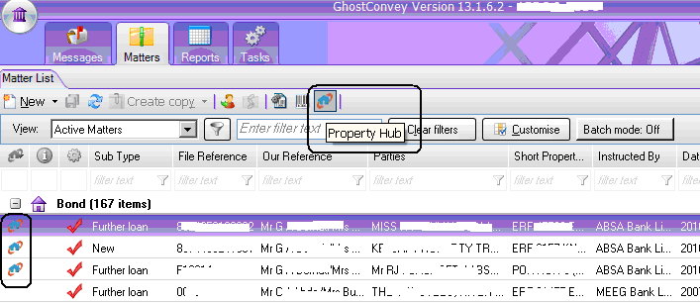

The Property Hub

Updates:
Will reflect the progress dates of the matter.
You can post a message, which will be shared with other collaborators.
You can post a file to be shared.

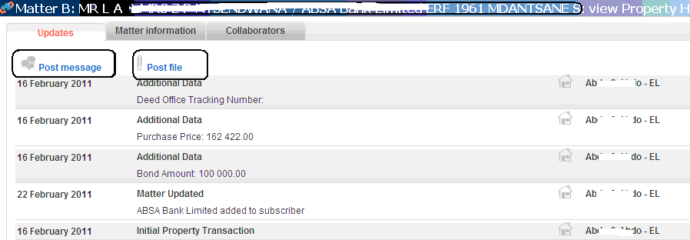

Suggested collaboration, a list of attorneys linked to the same property will be listed under Suggested collaboration.

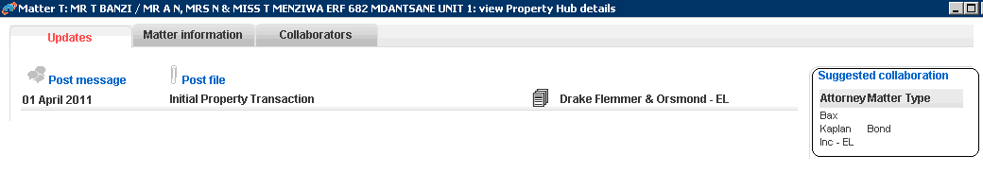

Matter Information
The Matter information tab reflects certain matter information.

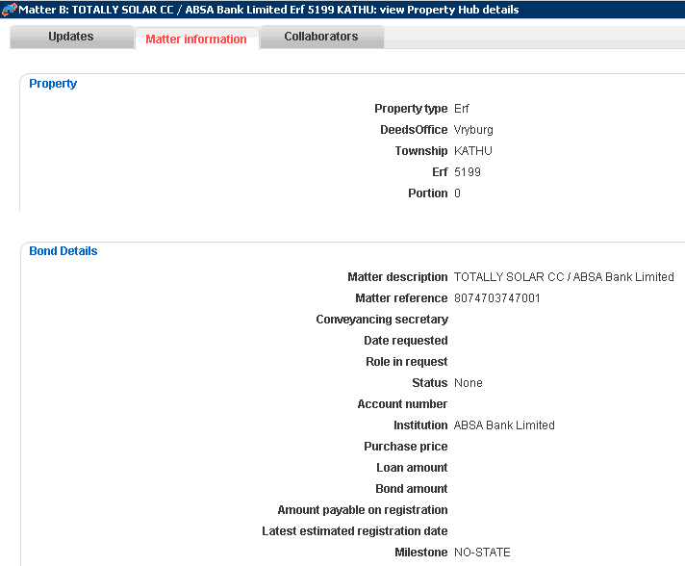

Collaborators
Is a list of collaborators on the matter, after selecting a collaborator under suggested collaboration, they will appear in this list on acceptance of your request.

On registration a Deeds office Registration report is uploaded to the Property Hub

